TITLE OF YOUR EXTENDED ABSTRACT (bold capital letters, 14pt)

Author, A¹, Author, B², and Author, C³ (12pt, underline the corresponding author)

¹Institution 1(TNR 12pt centered)
²Institution 2 (TNR 12pt centered)
³Institution 3 (TNR 12pt centered)
E-mail (corresponding author)

- INTRODUCTION (Bold, 12pt)
Authors are requested to submit an extended abstract not exceeding two (2) pages (including references) in .pdf format and should not exceed 5 MB. The extended abstract must include the title, author(s) and their affiliation, introduction, methods, results and discussion, conclusion and references. The extended abstract should be prepared on an A4-sized paper with 25 mm margins on all sides and typed with single spacing using size 12 Times New Roman font. All illustrations must be prepared inside of the main text. Selected papers will be published in the special issue of Fire and Materials.

- METHODS (Bold, 12pt)
The methods must be clearly stated and described in sufficient detail or with sufficient references.

- RESULTS AND DISCUSSION (Bold, 12pt)
The findings of the work should be described and discussed. Supporting figures, tables or images can be used as well. Figures and images should be numbered and figure headers should be placed under the figure or image; as for the tables, they should also be numbered and the table header should be placed at the top.

- CONCLUSION (Bold, 12pt)
Conclusions should include the principles and generalisations inferred from the results and theoretical and/or practical implications of the work.

4.1. Equations
Equations should be centered and numbered consecutively, as in Eq. [1].
(1 line spacing here)

a_{b} = q²l_{i}/(kρb (A_{p} - A_{i}))⁴ [1]

  - Tables and figures
Tables and figures should be numbered consecutively. Figures and tables should have a centered caption directly beneath the figure or above a table. Tables should follow the style shown in Table 1. Table captions should be in Italic 12pt “Time News Roman”, centered, and the texts in Table should be set in 12pt “Time News Roman” font.

Table 1. Caption heading for a table should be placed at the top of the table.
 | A | B | C | D
A | Aa | Ab | Ac | Ad
B | Ba | Bb | Bc | Bd
C | Ca | Cb | Cc | Cd
D | Da | Db | Dc | Dd
E | Ea | Eb | Ec | Ed

Use colour fonts, graphs and photographs. Figure 1 shows one example. Figure captions should be in 12pt “Time News Roman” font, italic, centered. When applicable, the texts in graphs, illustrations or images should be set to at least in 8pt.

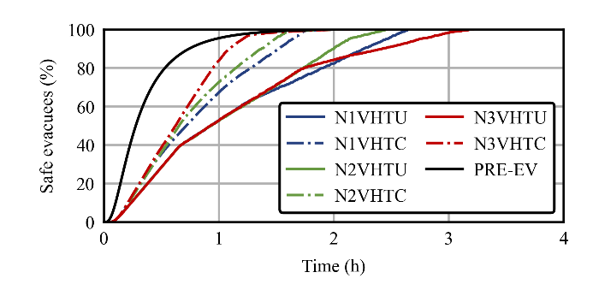
Figure 1. The caption for a figure should be placed below the figure and should be centered. (Use Italic “Time News Roman” font, size 12pt, no spacing between title and figure)

  - Units
Use SI as primary units. Imperial units may be used as secondary units (in parentheses). Avoid combining SI and CGS units.

- REFERENCES
References should be listed in alphabetical order according to APA Style e.g. American Psychological Association 7th Edition as in this example (Ronchi et al., 2025).

Ronchi, E., Ronkisson, H., & Ronchis, K. (2025). Made up reference to explain you how to use APA style. Journal of Inexistent Research, 1(1), 54–65.

